**HOME AUTOMATION**



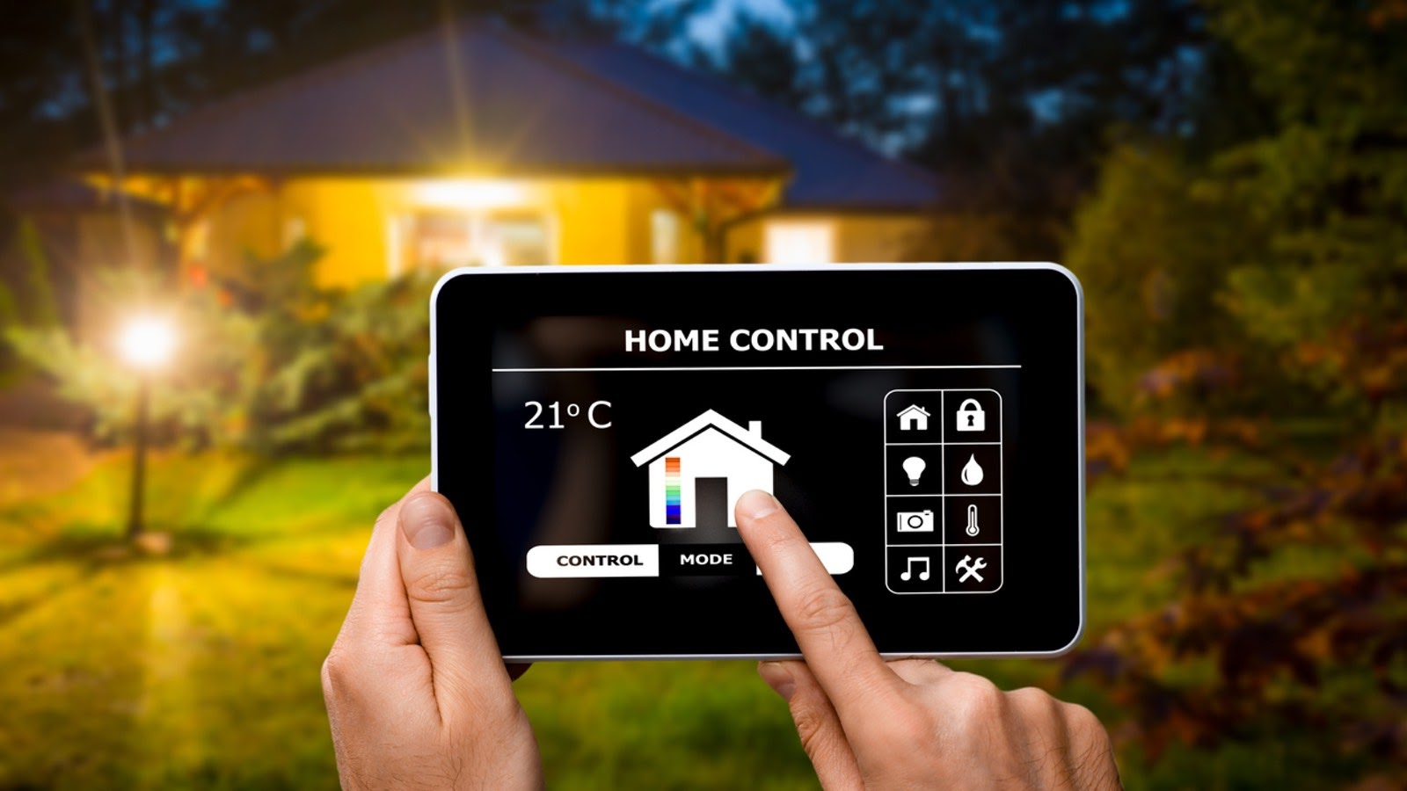

**PROBLEM STATEMENT:**

             Controlling devices through wires and managing them through manual switches are not energy efficient and convenient for the people using them. Managing all devices at a place is not completely possible with the wired and normal connections.

**AIM:**

             Designing a system that enables wireless control of devices in a room at home or workplace, without the direct usage of an Arduino board.

**OBJECTIVE:**

By using this home automation technique, different devices in a room can be accessed from one point at a home.

**COMPONENTS REQUIRED TO BUILTUP THE BASIC CIRCUIT:**

* Atmega 328
* Bluetooth HC-05 module
* Motor
* LED
* Resistor
* Toggle switch
* AND gate

**Working:**

* Initially the blynk app should be configured. In the Blynk app, buttons can be inserted according to the pin number to which the device(fan, light) is to be connected from the widget box.
* Bluetooth widget should also be placed in the blynk app layout from widget box.

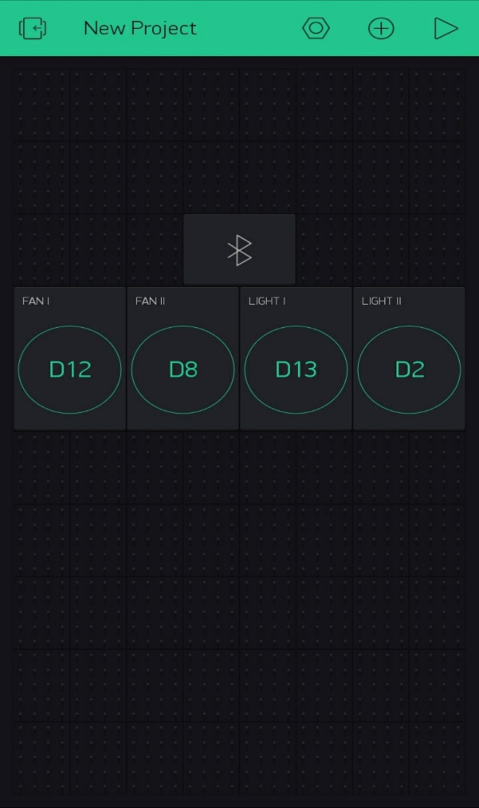 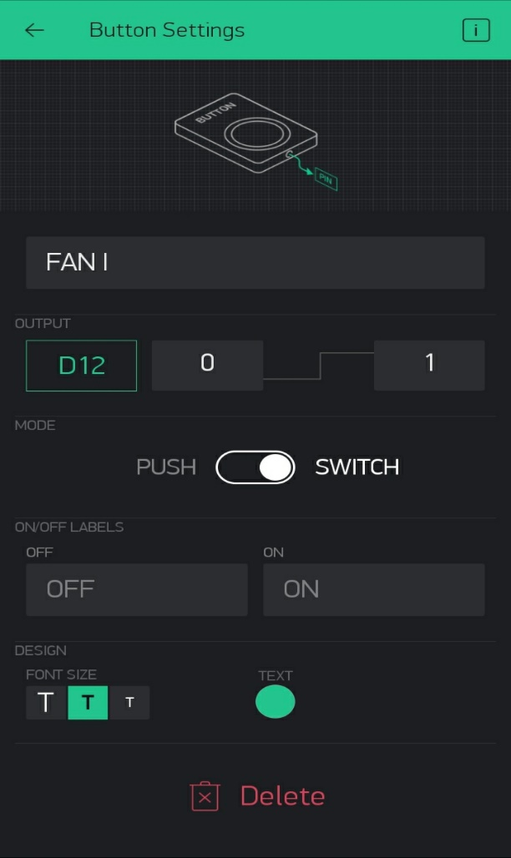

* For connecting the Bluetooth module to the Proteus simulation, Bluetooth should be turned on in the smart phone used and the COM port of the Bluetooth module(in proteus) should match with COM ports of Arduino IDE and the laptop in which proteus simulation is being done.
* Then by placing the auth code of the blynk app project in the Arduino code, Atmega 328 can be connected to it.
* To automate the process, Google assistant and IFTTT are used. The major role of IFTTT is to connect the Google assistant with the Blynk app.
* In IFTTT, webhooks is used to access the blynk app through google assistant and two applets should be created for on and off of a single device.
* Thus, the devices can be controlled through voice command and also through the buttons in blynk app.
* Here I have done the simulation for operating a device through blynk application.

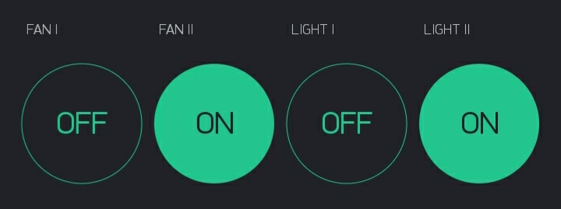

Turning on and off of the fans and lights can be done through the buttons in the blynk app.

**BLOCK DIAGRAM:**

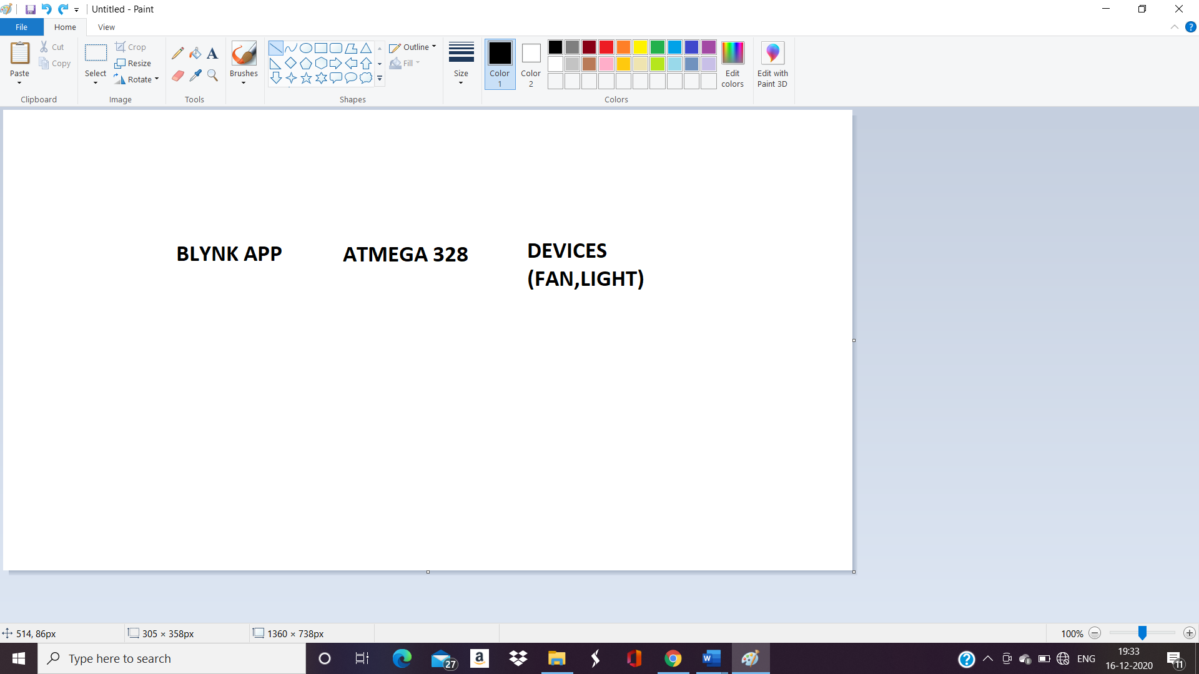

**CIRCUIT DIAGRAM:**

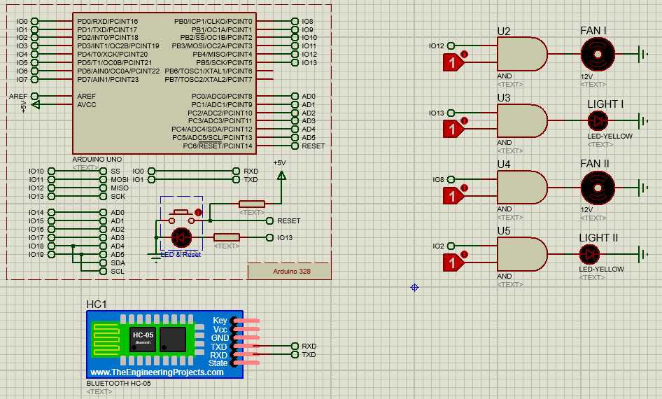

**PROJECT CODE:**

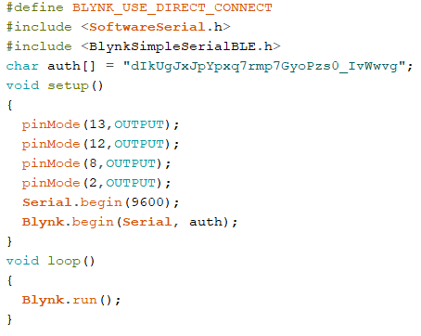

**MODEL / SIMULATION:**

Click on the below link for the simulation video

<https://youtu.be/3MM7NzY7ZXs>

[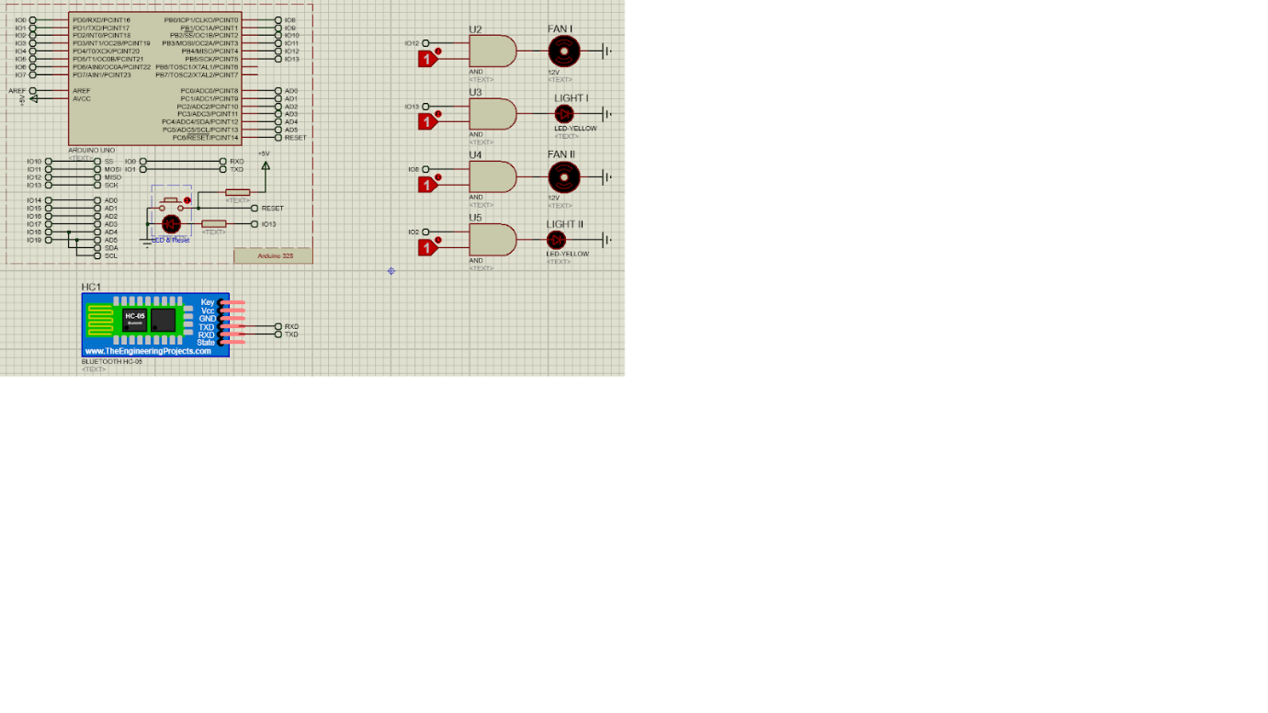](https://youtu.be/3MM7NzY7ZXs)